**Regulatory T Cells as a Potential Therapy in Chronic Obstructive Pulmonary Disease**

**Abril Bustamante1,3, Jade Xu2,3, Mariam Toma4, Benjamin Anderson4, Christine Basmajian, Ph.D.3,4**

1University of Pennsylvania, 2Rice University, 3Department of Internal Medicine, Division of Pulmonary and Critical Care, University of Michigan, 4Research Service, Ann Arbor VA Healthcare System

**ABSTRACT:**

**Purpose** Chronic Obstructive Pulmonary Disease (COPD) is the fourth leading cause of death in the U.S.. Despite significant advances in the understanding of COPD, regulatory T cells (Tregs) remain understudied. Tregs suppress inflammation but are decreased in COPD patients. Previous studies have varied results when Tregs were used as a single population. Thus, this project aims to investigate the therapeutic contributions of four Treg subsets (ICOS Single Positive (SP), CD25 SP, Double Positive, Double Negative (DN)) to restore Tregs levels in COPD.

**Methods** Tregs were isolated from the spleens of GFP-transgenic mice. For each Treg subset, expression of chemokine receptors CCR6, CXCR3, and CCR7 were measured using flow cytometry. Functionality was assessed via chemotaxis assay in which Treg migration towards three respective chemokine ligands (CCL20, CXCL11, CCL21) was measured.

**Results** Previous lab results showed that RNA transcripts for CCR6 and CXCR3 increased while CCR7 transcripts decreased in ICOS SP Tregs compared to DN Tregs. Protein transcripts showed similar CXCR3 and CCR7 expressions. The chemotaxis assay revealed that the ICOS SP Tregs did not have preferential migration towards any ligand while DN Tregs preferentially migrated towards CXCL11 and CCL21 ligands.

**Conclusion** An examination of specific Treg subsets for improved therapeutic outcomes in COPD was explored. Despite increased RNA transcripts for CCR6 and CXCR3 in ICOS SP Tregs, their lack of preferred migration towards any ligand suggests potential interference with other receptors. Superior migration of DN Tregs towards specific ligands suggests their potential in targeting specific sites. Further studies are needed to assess the efficacy of Treg-based therapies in mitigating COPD.

**Keywords:** COPD, chemokine receptor, inflammation, CD4, Tregs, migratory behavior, ICOS, CD25

**Introduction**

Chronic Obstructive Pulmonary Disease (COPD) is a prevalent and debilitating condition within the United States and many people with COPD remain undiagnosed. Cigarette smoking is the leading cause of COPD; however, not all smokers will develop the disease. Moreover, COPD can result from exposure to inhalation hazards such as biomass fuels in developing countries. Characterized by progressive and irreversible lung damage, COPD cannot be treated to halt or reverse its damage. COPD is an umbrella term that encompasses emphysema and chronic bronchitis, which manifest differently. Emphysema involves the breakdown of alveoli which reduces the surface area available for gas exchange. In contrast, chronic bronchitis involves inflamed air ducts and excessive production of mucus, leading to clogged airways. Disparities in pathology may lead to distinct manifestations of emphysema and chronic bronchitis.

The human immune system identifies and responds to foreign proteins; however, it rarely targets its own proteins. Autoimmune conditions occur when the immune system mistakenly targets autoantigens, attacking organs and tissue through cell-mediated and humoral mechanisms. Lacking proper immune function that excludes reactions against autoantigens is a common cause of autoimmune diseases.[1] Regulatory T cells

(Tregs) have been reported to contribute significantly in controlling autoreactivity and reducing adverse effects, preventing autoimmunity-mediated pathological conditions. Tregs constitute about 5 -10% of a specialized subpopulation of CD4+ T cells that function as key inflammatory response regulators that maintain immune tolerance.[2][3] CD4+ T cells are a specific type of helper T cells that play a significant role in fighting infection and disease. Tregs are largely characterized by the transcription factor and marker foxhead box protein P3 (FoxP3). Functioning as a transcription factor with a conserved 100 amino acid DNA-binding domain, FoxP3 adopts a winged helix structure, termed the forkhead box. It plays a significant role in preventing autoimmune diseases and maintaining self-tolerance by regulating the function of CD4+ Tregs. Tregs prevent autoimmune diseases by suppressing various cell types such as natural killer (NK) cells. Scientific evidence indicates that a deficiency in Tregs leads to autoimmunity.[4][5] For this reason, there have been several studies that have reported Tregs to contribute to the development of reliable and effective therapeutic regimens for treating autoimmune diseases.[6]

NK cells are crucial in eliminating virally infected cells, cells under stress, and malignantly transformed cells. A high concentration of smoking can induce stress in epithelial cells, which can become targets for NK cells due to an increased expression of stress-related ligands. NK cells determine whether to kill another cell based on a balance of inhibitory and activating signals. In patients with COPD, lung NK cells in particular exhibit cytotoxic effects against autologous epithelial cells in the lungs, targeting stressed epithelial cells. Prior research has detected a high level of annexin staining, a marker that measures early apoptosis, when epithelial cells were cultured with NK cells alone, indicating evidence of early apoptosis.[7]

In patients with COPD, there is a deficiency of Tregs in lung tissue. Given the ability of Tregs to suppress NK cell cytotoxicity, it is possible that decreased levels of Tregs is contributing to the NK cells’ cytotoxicity towards lung epithelial cells, leading to COPD progression. Using both murine and human models that have been exposed to cigarette smoke, Tregs are shown to initially increase in subjects exposed to cigarette smoke. Humans exhibit a small increase between non-smokers and smokers without COPD[8]. Likewise, there is a small population of Tregs - 10% percent - in the murine model not exposed to smoke (air). After 8 weeks, the mice exposed to cigarette smoke showed a FoxP3 expression of about 17% (Figure 1). FoxP3 is a cell-specific marker for Tregs, indicating the level of Tregs within the subjects. In both the human and murine models, the data suggests that Tregs have an initial immune response to smoking.

Figure 1. Murine model of the comparison of Tregs between mice exposed to cigarette smoking (CS) and air, indicating an increase in Treg population in mice exposed to smoke after 8 weeks.

After prolonged exposure to cigarette smoke, the data was indicative of a decrease in Tregs in smokers with established COPD, suggesting a dynamic regulation of Tregs in response to smoking and COPD progression. Referring to Figure 2, there is less FoxP3 expression in subjects with COPD than smokers without COPD (NAO), suggesting impaired Treg function. Similarly, there is a drop in FoxP3 expression after 24 weeks in the mice exposed to cigarette smoking (CS) in Figure 3. This is unfavorable as FoxP3, an important maker for Treg identity and function, is assumed to play a significant role in suppressing COPD and is essential in maintaining immune balance. Because there are similar Treg levels between the human and murine models under these conditions, using a murine model for the rest of this study is representative of humans.

Figure 2. Human lung tissue model of FoxP3 expression comparison between NAO (no airway obstruction) group and COPD.[9]

Figure 3. Murine model of drop in FoxP3 expression after 24 weeks in mice exposed to cigarette smoking (CS).

To potentially restore Tregs in sites of inflammation to target inflamed tissue, the use of chemokine attractants was explored. Cytokines are significant in developing immune responses. A structured population of cytokines, known as chemokines, controls the movement and migration of cells.[10] Treg subsets have distinct chemokine receptor expressions, influencing their localization and migration patterns. Treg subsets migrate towards specific chemokine ligands according to their chemokine receptors: CCR6, CCR7, and CXCR3. The ligands for the chemokine receptors are as follows: CXCL11 for CXCR3, CCL20 for CCR6, and CCL21 for CCR7. This experiment centers on migration as it implies the functionality of the chemokine receptors.

Inflammatory sites affect Treg function, potentially reducing their suppressive abilities. As a result, identifying Treg subsets that remain suppressive and migrate to desired sites, such as the lungs where NK cells are active, is crucial. The CCR6 and CXCR3 receptors circulate to the lungs, which is important for targeting the inflammatory sites present in COPD patients, making them the most suitable for therapeutic applications. The CCR6+ Tregs accumulate in sites of inflammation as they exhibit more markers associated with effector status, destroying potential threats. Contrastingly, CCR7+ Tregs recirculate to lymph nodes, characterized by a naive phenotype. Showing the expression of these three chemotaxis receptors is important for Treg localization to appropriate environments.

Despite substantial supporting evidence, the potential of effective and reliable Treg-based cellular therapies for autoimmune disease remains uncertain.

Significant knowledge gaps and various disagreements in Treg suppression mechanisms underscore the need for further in-depth research.

**Research Objectives**

Tregs have been used in various clinical trials, but they have not been extensively tested in COPD. These clinical results varied when Tregs have been used as a single population; however, exploring Treg subsets may produce more effective outcomes. Because the subsets differ in terms of localization, suppressive potential, and stability, which could have therapeutic implications, distinct Treg subsets were tested for their ability to suppress lung inflammation. Understanding these differences is significant for developing strategies that are effective against chronic inflammation and immune dysfunction in COPD. While previous clinical results have underscored the importance of Tregs in immune regulation, this study specifically provides insights into the functional differences among Treg subsets to identify the most stable and suppressive subset towards NK’s cytotoxicity in the lungs.

**Materials and Methods**

To test the hypothesis that Treg subsets vary in migratory and functional properties, chemokine receptor staining was performed to measure their expressions in each Treg subset. To test the functionality of the Treg subsets, a chemotaxis assay was used to measure the percentage of cells that migrated towards the chemokine ligands.

**Source of Tregs**

Cells were harvested from the spleens of mice that have been genetically modified to have the GFP strain, allowing them to autofluoresce in response to the expression of the transcription factor FoxP3. The spleens have shown to provide a rich source of Tregs for data collection.

**Isolation of CD4+ Cells**

Using standard cell isolation techniques that involved performing tissue to single cell suspension and employing gradient centrifugation, monocytes and lymphocytes were isolated from mononuclear cells. An additional purification and enrichment process was used on the isolated mononuclear cell population to sort out the target T cell population. Immunomagnetic beads, which have antibodies for all cell types except CD4s, were added to the solution, marking non-CD4 cells with magnetic beads in negative isolation. After being placed in a magnet for five minutes, unbound cells were collected. This process consisted of depleting multiple cell types, including CD8+ T cells and CD19+ B cells, allowing for the removal of unwanted cell types.

**Chemokine Receptor Staining**

An isotype was made to act as nonspecific binding with the same staining, including all the markers for CD45 and CD4. Because the isotype doesn’t bind to antibodies, it acts as the “zero” in this experiment. The cell samples were washed with a Fix/Perm Reagent that consisted of Perm Diluent and Fixation/Permeabilization Concentrate. The samples were then stained with the following cell markers for the corresponding cellular components:

|  |  |
| --- | --- |
| **Cell Surface Markers** | **Intracellular Markers** |
| AF700 - CD45  BV605 - CD4  PeCy7 - ICOS  PerCP-Cy5.5 - CD25  Apc-Cy7 - CXCR3  APC - CCR7  Pe - CCR6 | AF488 - FITC (FoxP3) |

The samples were then refrigerated until they could be run for analysis using flow cytometry.

**Chemotaxis Migration Assay**

The same cell isolation protocols were used for the chemotaxis experiments. In order to measure spontaneous movement and set the zero for our data, a control well was filled with 375 uL Phosphate Buffered Saline (PBS). Similarly, an isotype well was filled with 375 uL PBS to be used as a negative control to distinguish between specific and nonspecific antibody staining. Using a transwell plate, specific chemo-attractant solutions (varying volumes of PBS with chemokine ligands: CCL20, CCL21, and CXCL11) were placed in the bottom wells. Aside from the control and isotype wells, there was one type of ligand in each well of varying ligand concentrations: 25 ng/ml, 50 ng/ml, and 100 ng/ml. Each bottom well contained 375 uL of solution. An adhesive filter was positioned over the bottom chamber, following the addition of 200 uL of isolated CD4+ cells into the top wells as visualized in Figure 4. This chemotaxis assay allows for cells in the top chamber to migrate specifically through the filter to join the solution below if there is ligand attraction. If minimal to no migration occurred, there was no attraction between the cells and the chemoattractants. After incubation for an hour, the bottom and top compartments were collected in flow tubes for staining.

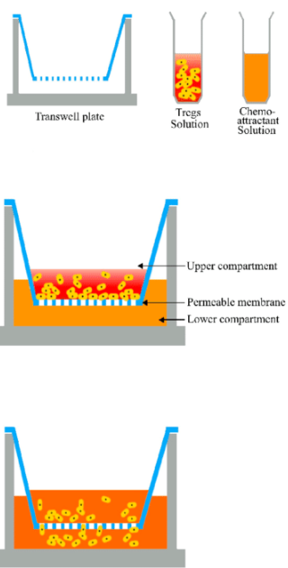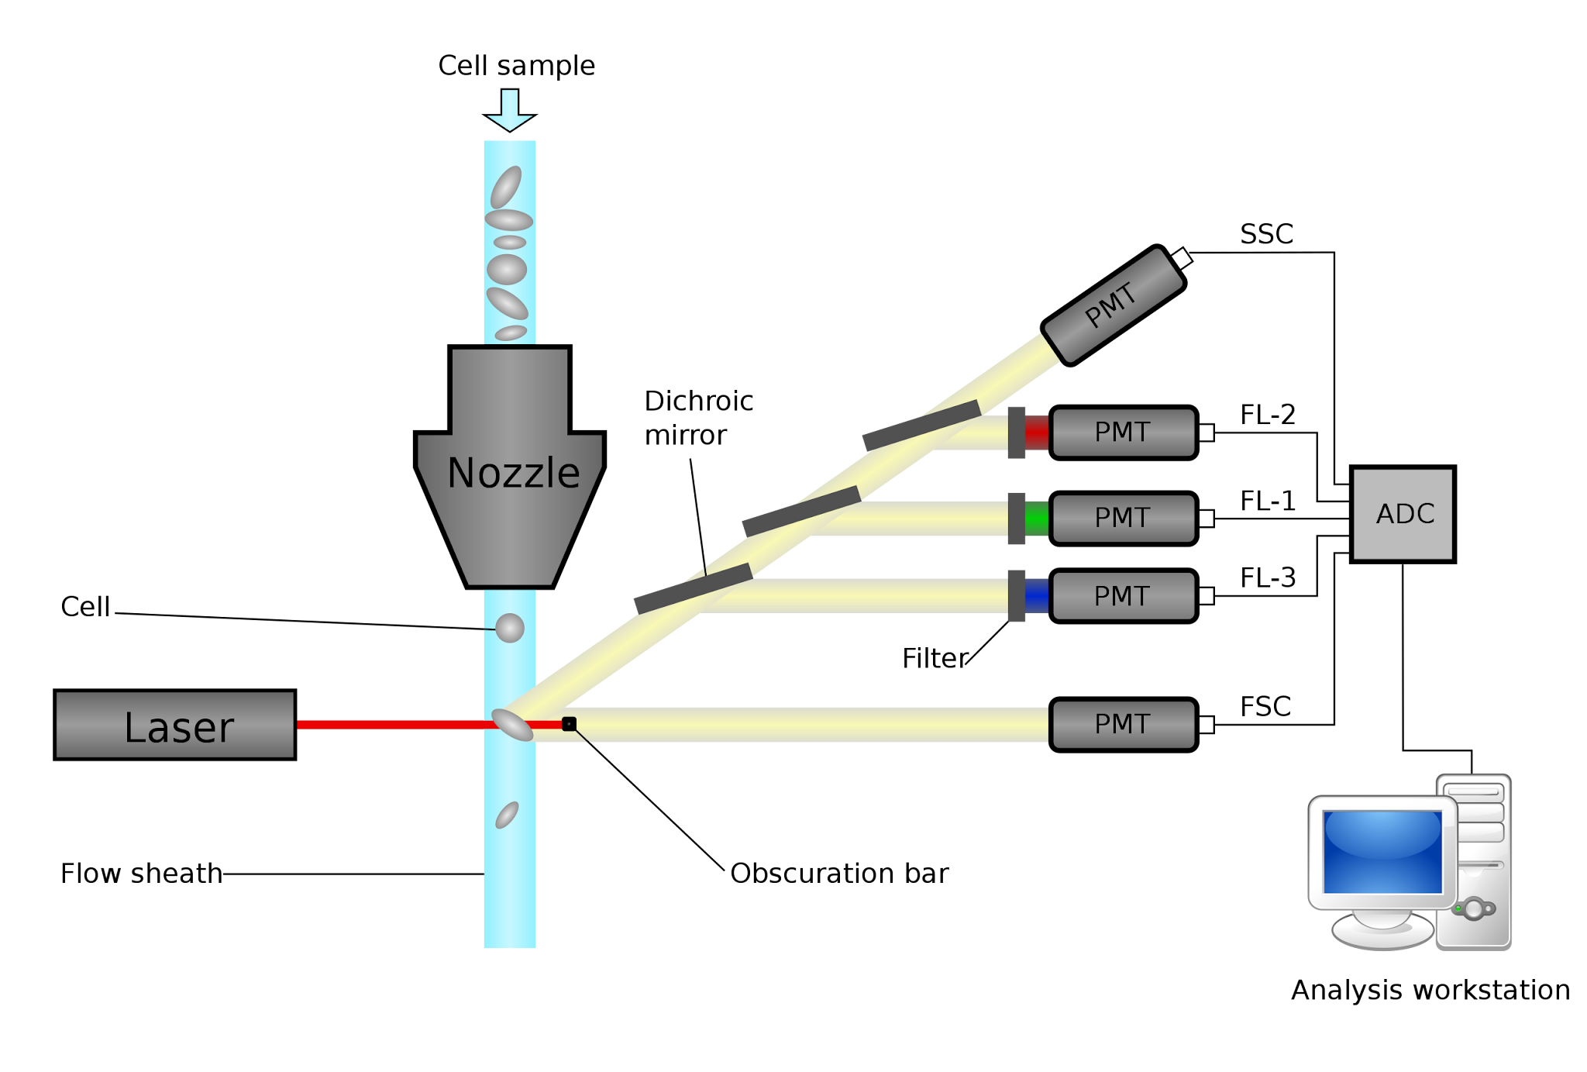

Figure 4. Visual illustration of a transwell plate with Tregs in top chamber and PBS-chemoattractant solution in bottom chamber, divided by an adhesive filter that acts as a permeable membrane.[11]

**Marker Staining**

The cell population was then stained using the following distinguishing cell-specific markers for CD4+ Tregs based on availability in the lab: AF700 or APC for CD45, BV605 or Pe for CD4, PeCy7 for ICOS, APC-Cy7 or PerCP-Cy5.5 for CD25, and BB515 for FITC (FoxP3). This procedure marked each of the Treg subsets to be isolable in the flow cytometer, measuring the percentage of Treg subsets that migrated through the adhesive filter.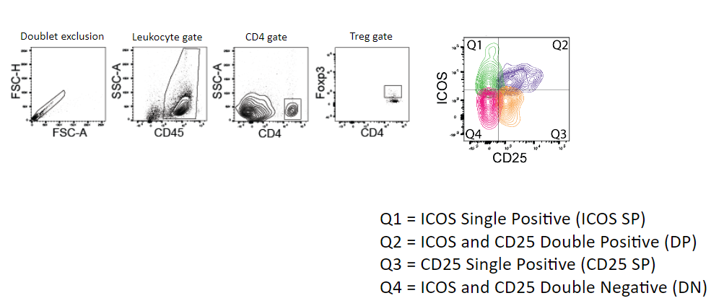

The samples were then refrigerated until they could be run for analysis using flow cytometry.

**Flow Cytometry**

The chemokine receptor staining and chemotaxis experiment samples were then run on flow cytometry. This instrument measures the fluorescence intensity generated by the fluorescently labeled markers, identifying multiple cell types. The sample was suspended in fluid sheath to flow one cell at a time through the flow cytometer instrument (Figure 5), passing through a laser beam. The scattered and fluorescent light was emitted from the laser to measure the fluorescent dyes and then counted and sorted by individual cell type. Each dye was excited at a different wavelength to distinguish them by using various markers. Optical filters and lenses were used to move bands of light wavelengths around the detection system, producing the photocurrent for analysis.[12] This technique allows several cell parameters to be measured, including but not limited to cell count, size, complexity, and fluorescence.

Figure 5. Schematic diagram of flow cytometry, illustrating the sheath fluid, laser, simplified optics (excluding focusing components), photomultiplier tubes (PMTs), analog-to-digital converter, and analysis workstation.[13]

**Treg Subset Sorting Strategy**

The sorted cells were then analyzed using Flowjo software. This software allowed the implementation of a gating strategy to isolate Tregs from lymphocytes, focusing on the CD4 cell population, as visualized in Figure 6. This allows the Treg subsets to be isolated into four subsets: ICOS single positive (ICOS SP), ICOS and CD25 double positive, CD25 single positive, and ICOS and CD25 double negative (DN). This sorting strategy measured the cell count that migrated, demonstrating the functional properties of each Treg subset.

Figure 6. Gating strategy to isolate the four Treg subsets from the CD4 cell population.

**Results**

The data collected were RNA and protein expressions of the chemokine receptors as well as the migration counts from the chemotaxis assay for each Treg subset.

The ICOS+ single positive (SP) Treg subset had increased RNA transcripts for both CCR6 and CXCR3 chemokine receptors, while it had decreased levels of the CCR7 chemokine receptor transcript (Figure 7). Contrastingly, the double negative (DN) Treg subset had an increased expression of the CCR7 chemokine receptor while it had decreased levels of the CCR6 and CXCR3 chemokine receptors. Because the RNA data was collected first, the protein data was anticipated to confirm the results of the RNA data.

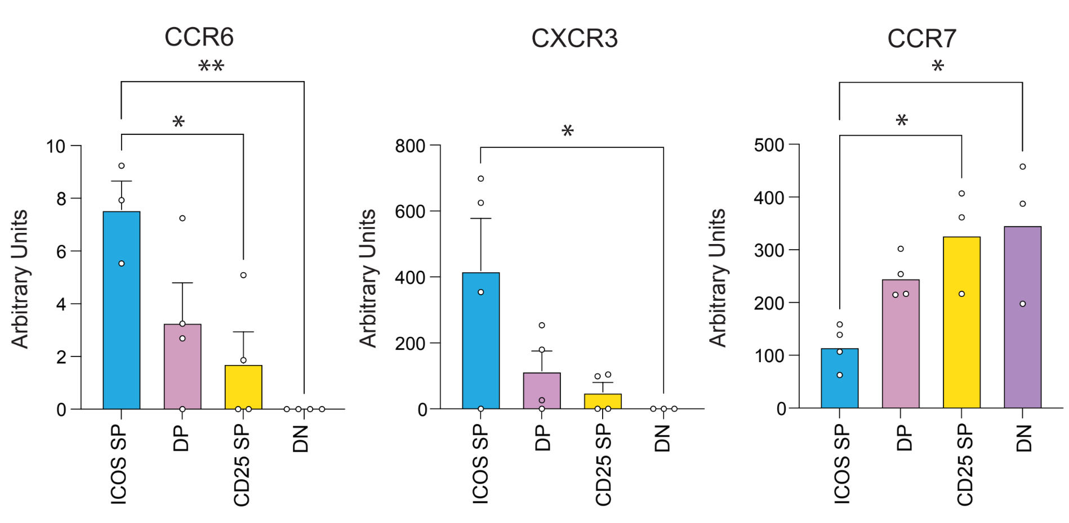

Figure 7: RNA expression of chemokine receptors in ICOS SP, DP, CD25 SP, and DN Treg subsets.

The protein transcripts for CXCR3 and CCR7 chemokine receptors demonstrated similar patterns to the respective RNA expressions; there was high protein expression of CXCR3 in the ICOS+ SP Treg subset and CCR7 in the DN Treg subset (Figure 8). However, there was not a high level of CCR6 in the ICOS+ SP Treg subset as expressed in the RNA transcripts.

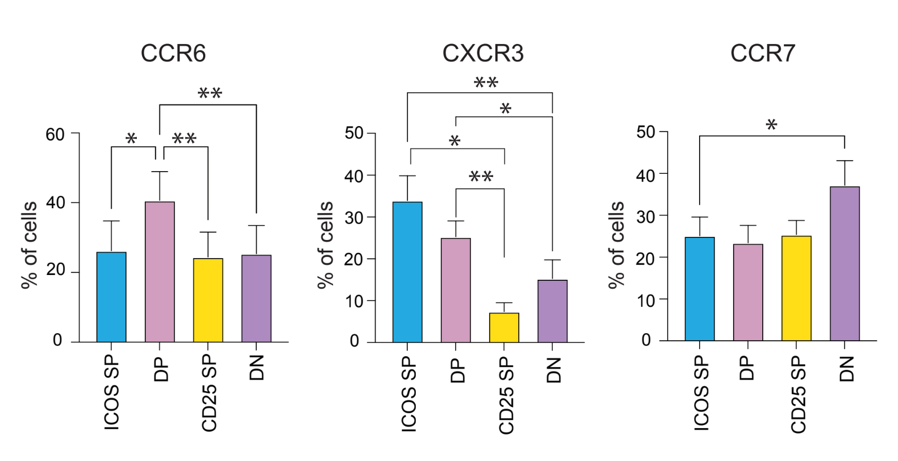

Figure 8: Protein expression of chemokine receptors in ICOS SP, DP, CD25 SP, and DN Treg subsets.

Due to the observation of strong, clear differences in the ICOS+ SP and DN Tregs in the RNA data, the specific functionality of these subsets were measured (Figure 9). Unlike the RNA expressions, the chemotaxis results in Figure 9 demonstrated that the ICOS SP Treg subset did not show preferential migration towards CCL20 and CXCL11, the ligands for CCR6 and CXCR3. On the other hand, the DN Treg subset had superior migration towards both CXCL11 and CCL21 ligands.

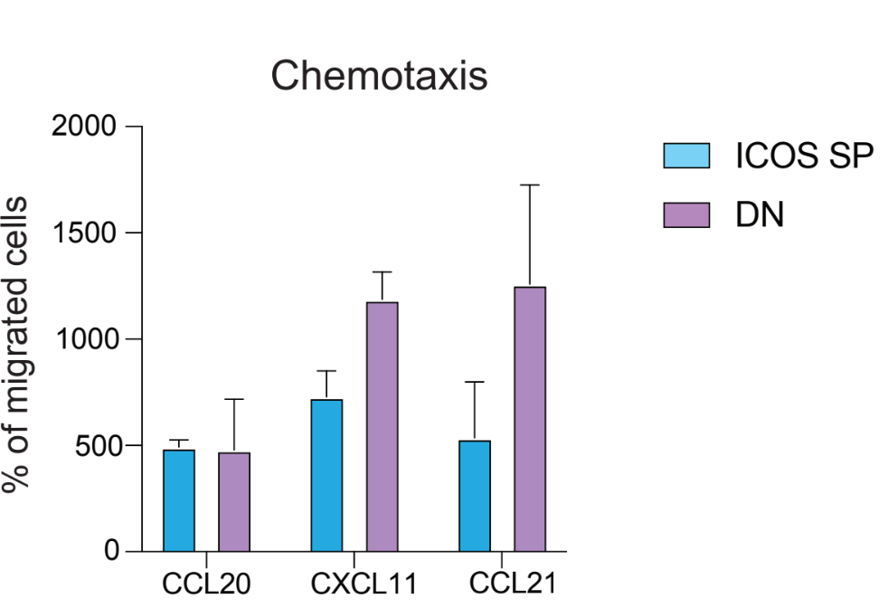

Figure 9: Measure of chemotaxis migration of ICOS SP and DN Treg subsets towards CCL20, CXCL11, and CCL21 ligands.

**Discussion**

Our study was aimed at examining the migratory patterns and suppressive potential of Treg subsets towards inflamed tissue, particularly the ICOS+ SP and DN subsets, in the context of their chemokine receptor expressions and localization.

**RNA and Protein Expression Patterns**

The RNA expressions data indicated distinct chemokine receptor profiles among the Treg subsets. The results demonstrated that the ICOS+ SP Tregs had a high expression of RNA transcripts for CCR6 and CXCR3 and decreased CCR7 transcripts compared to the DN Tregs. The low levels of CXCR3 and CCR6 receptor expressions in the DN Tregs did not necessarily imply the absence of these receptors, but rather a limitation in detection sensitivity. At the RNA level, this suggests that the ICOS+ SP Tregs are primed for migration towards the CCR6 and CXCR3 ligands, CCL20 and CXCL11 respectively, located in inflamed tissues. The DN Tregs appear more disposed to migrate towards the CCR7 ligand - CCL21 - associated with lymph nodes.

However, the protein expression data did not match the RNA expression data in all respects. The protein expression for CCR6 did not demonstrate a corresponding increase in ICOS+ SP Tregs while the protein levels for CXCR3 and CCR7 did align with the RNA transcripts. The discrepancy in the CCR6 RNA and protein expressions highlight the complexity of post-transcriptional regulation, suggesting that RNA transcriptions alone may not entirely predict protein function and/or cellular behavior.

**Chemotaxis Assay Findings**

The DN Tregs suggest a functional response that is consistent with their chemokine receptor expressions. The DN subset had predominant migration towards specific ligands, indicating their potential for targeting specific sites in therapeutic strategies directed at modulating immune responses. Contrary to expectations based on their RNA expression profiles, the ICOS+ SP Tregs did not show preference for any chemokine ligands tested. The lack of anticipated migration patterns towards the corresponding ligands for CCR6 suggests the presence of other factors, including additional regulatory mechanisms and/or unmeasured chemokine receptors. These factors may be interfering with the migratory behavior of the ICOS+ SP Tregs or interacting with the tested ligands, overriding the expected patterns based on the RNA data.

The data highlighted clear differences in the migratory behavior of the Treg subsets, demonstrating the complexity of chemokine receptor-ligand interactions and the potential influence of other factors not captured in our study.

**Implications for Treg Functionality in COPD**

The lack of preferential migration of ICOS+ SP Tregs towards the tested chemokine ligands raises important questions about their migratory and functional roles in inflamed tissues. Although these cells express increased levels of the CCR6 and CXCR3 chemokine receptors at the RNA level, their migratory capacity may be guided by other factors such as competing signals or regulatory layers. A more nuanced understanding of the behavior of Treg subsets and the factors that influence their localization and function within tissues is needed.

The demonstrated ability of DN Tregs to migrate towards the CXCL11 and CCL21 chemokine ligands presents a promising avenue for therapies targeted at directing Tregs to specific sites in the body. Their preferred migration suggests they may have a crucial role in modulating immune responses within both lymph nodes and peripheral tissues.

**Limitations**

Strengths of this study include the translational nature of the murine model which allows us to study Tregs and explore their therapeutic potential. Additional strengths include the multi-pronged approach to study the chemokine receptor depression on each Treg subset. By analyzing RNA expression, protein expression, and looking at the functionality of the chemokine receptors with the chemotaxis assay, we are developing a thorough understanding of the role of individual chemokine receptors on each subset. It is important to recognize possible limitations in this study. In a broader scope, COPD is an umbrella term encapsulating chronic bronchitis and emphysema. While this study focused on COPD in its entirety, research findings may differ according to each subtype. Furthermore, during the chemotaxis experiments, the protocol was changed relatively frequently in order to produce more effective results. For instance, initial experiments used Lymphocyte Culture Media (LCM), which consists of fetal bovine serum that influenced migration, masking the effect of the tested chemoattractants. Hence, the media was changed to non-serum containing Phosphate Buffered Saline (PBS).

**Future Directions**

The CXCR3 chemokine receptor has three corresponding ligands: CXCL9, CXCL10, and CXCL11.[14] Although the RNA and protein expressions did show similar patterns for CXCR3, the role of other chemokine ligands beyond CXCL11 that was tested should be investigated to further elucidate the migratory and functionality patterns of Treg subsets. This could provide deeper insights into other signals that drive Treg migration in inflamed tissues. In addition, experiments that expand receptor profiling should be conducted. In order to fully understand the chemokine receptors expressed by the Treg subsets, other receptors that were not tested should be identified due to their possible influence on migration. This will aid in predicting and enhancing the migratory dynamics and interaction of Treg subsets.

Furthermore, the Treg subsets should be examined in vivo. In murine models, the composition and behavior of the Treg subsets should be examined in the lungs to understand how they function within the lung tissue. Treg subset localization should also be tracked to follow their interactions within tissues, elucidating their functional destinations within bodies. This may provide valuable information for developing targeted therapies.

By addressing these future directions, we aim to refine our understanding of Treg subset behaviors and functionality, enhancing their potential for effective therapeutic strategies for modulating immune responses in COPD and other inflammatory diseases.

**Conclusion**

This study underscored the differing roles and therapeutic potential of distinct Treg subsets in the context of inflammation and immune regulation.It is possible to develop more personalized and effective therapeutic strategies by centering on Treg subsets with distinct characteristics, differing in functional and migratory properties. If the most effective Treg subset can be identified to have preferred migration towards inflamed lung tissue, targeted therapies can be developed to increase function and recruitment of this subset in COPD patients. This approach could potentially restore immunity by decreasing the harmful effects of the NK cells’ cytotoxicity towards lung epithelial cells, reducing the localized inflammation and tissue damage in COPD. By advancing our understanding of Treg function and biology, this study paves the way for more effective treatments to improve the quality of life for COPD patients.

**Acknowledgements**

We thank Christine Basmajian for her assistance in data analysis and study administration and Ben Anderson and Mariam Toma for their assistance in data acquisition.

**Funding**

This study was funded by the National Health Science Institute and the Department of Veteran Affairs in Ann Arbor, MI.

**References**

1. Arellano, B., Graber, D. J., & Sentman, C. L. (2016). Regulatory T cell-based therapies for autoimmunity. Discovery medicine, 22(119), 73–80

2. Mikami, N., Kawakami, R., & Sakaguchi, S. (2020). New Treg cell-based therapies of autoimmune diseases: towards antigen-specific immune suppression. Current Opinion in Immunology, 67, 36–41 https://doi.org/10.1016/j.coi.2020.07.004

3. Mamo, T., Hippen, K. L., MacMillan, M. L., Brunstein, C. G., Miller, J. S., Wagner, J. E., Blazar, B. R., & McKenna, D. H. (2022). Regulatory T Cells: A Review of Manufacturing and Clinical Utility. Transfusion, 62(4), 904–915. https://doi.org/10.1111/trf.16797

4. Trzonkowski, P., Bieniaszewska, M., Juścińska, J., Dobyszuk, A., Krzystyniak, A., Marek, N., Myśliwska, J., & Hellmann, A. (2009). First-in-man clinical results of the treatment of patients with graft versus host disease with human ex vivo expanded CD4+CD25+CD127− T regulatory cells. Clinical Immunology, 133(1), 22–26. https://doi.org/10.1016/j.clim.2009.06.001

5. Mukhatayev, Z., Ostapchuk, Y. O., Fang, D., & Le Poole, I. C. (2021). Engineered antigen-specific regulatory T cells for autoimmune skin conditions. Autoimmunity Reviews, 20(3), 102761. https://doi.org/10.1016/j.autrev.2021.102761

6. Arellano, B., Graber, D. J., & Sentman, C. L. (2016). Regulatory T cell-based therapies for autoimmunity. Discovery medicine, 22(119), 73–80.

7. Freeman, C. M., Stolberg, V. R., Crudgington, S., Martinez, F. J., Lan, M., Chensue, S. W., Arenberg, D. A., Meldrum, C. A.,

McCloskey, L., & Curtis, J. L. (2014). Human CD56+ Cytotoxic Lung Lymphocytes Kill Autologous Lung Cells in

Chronic Obstructive Pulmonary Disease. PloS One, 9(7), e103840–e103840. https://doi.org/10.1371/journal.pone.0103840

8. Elisia, I., Lam, V., Cho, B., Hay, M., Li, M. Y., Yeung, M., Bu, L., Jia, W., Norton, N., Lam, S., & Krystal, G. (2020). The effect of smoking on chronic inflammation, immune function and blood cell composition. Scientific Reports, 10(1), 19480. https://doi.org/10.1038/s41598-020-76556-7

9. Freeman, C. M., McCubbrey, A. L., Crudgington, S., Nelson, J. D., Martínez, F. J., Lan, M., Washko, G. R., Chensue, S. W., Arenberg, D. A., Meldrum, C. A., McCloskey, L., & Curtis, J. L. (2014). Basal Gene Expression by Lung CD4+ T Cells in Chronic Obstructive Pulmonary Disease Identifies Independent Molecular Correlates of Airflow Obstruction and Emphysema Extent. PLOS ONE, 9(5), e96421–e96421. https://doi.org/10.1371/journal.pone.0096421

10. Agita, A., & Alsagaff, M. T. (2017). Inflammation, Immunity, and Hypertension. Acta Medica Indonesiana, 49(2), 158.

11. Irekeola, Ahmad & E. A. R., Engku Nur Syafirah & Lazim, Norhafiza & Mohamud, Rohimah & Yean, Chan & Shueb, Rafidah. (2020). Technical Considerations in Ex Vivo Human Regulatory T Cell Migration and Suppression Assays. Cells. 9. 487.

12. McKinnon, K. M. (2018). Flow Cytometry: an Overview. Current Protocols in Immunology, 120(1), 5.1.1–5.1.11. https://doi.org/10.1002/cpim.40

13. O'Neill, Kieran & Aghaeepour, Nima & Spidlen, Josef & Brinkman, Ryan. (2013). Flow Cytometry Bioinformatics. PLoS computational biology. 9. e1003365. 10.1371/journal.pcbi.1003365.

14. Wang, X., Zhang, Y., Wang, S., Ni, H., Zhao, P., Chen, G., Xu, B., & Yuan, L. (2022). The role of CXCR3 and its ligands in cancer. Frontiers in oncology, 12, 1022688. https://doi.org/10.3389/fonc.2022.1022688